FinTech Product Analytics: Funnel, Retention & Revenue Analysis

1. Project Overview
FinTech Product Analytics: Funnel, Retention & Revenue Analysis is a data analytics project aimed at understanding user engagement, retention, conversion, and revenue performance within a FinTech platform. The analysis was conducted on a dataset containing 72,746 records and 1,114 users to track the complete customer journey from signup and KYC verification to transactions, subscriptions, and long-term product usage.
The project focuses on three key areas: Product Analytics (DAU, MAU, Funnel, Conversion, Feature Usage), Retention Analytics (Retention, Cohort Analysis, Churn), and Revenue Analytics (MRR, ARPU, Revenue by Country). Using PostgreSQL, Python, and Tableau, the project identifies user behavior patterns, onboarding bottlenecks, retention trends, and revenue drivers to support data-driven business decisions and product improvements.

Key Project Achievements
- Analyzed 72,746 records across 1,114 users to map the user journey from signup, KYC verification, transactions to subscription revenue
- Tracked 15+ KPIs, identifying a 17.90% drop-off in the KYC funnel and Balance Check as the driver of 80% of daily user engagement
- Performed cohort and churn analysis; calculated monthly subscription revenue and average earnings of 4,246.51 monetary units per user
- Developed interactive Tableau dashboards to visualize user acquisition, funnel conversion, revenue trends, feature adoption and KPIs

2. Dataset Summary
The dataset consists of four interconnected tables representing different aspects of a FinTech product ecosystem.
a. fintech_users
This is the master user table containing customer registration and onboarding information.
Columns:
user_id, signup_date, kyc_date, country, channel
Primary Key:
user_id
b. fintech_feature_usage
This table records user interactions within the application and tracks engagement events.
Columns:
user_id, event_name, timestamp

Examples:
login, app_open, notification_click, check_balance
Foreign Key:
user_id
c. fintech_transactions
This table stores financial transaction records performed by users.
Columns:
user_id, amount, category, timestamp
Foreign Key:
user_id
d. fintech_subscriptions
This table contains premium subscription information and recurring revenue details.
Columns:
user_id, plan_level, mrr, start_date, end_date
Foreign Key:
user_id
The dataset supports complete product analytics by combining user acquisition, onboarding, engagement, retention, transactions, subscriptions, and revenue information within a single ecosystem.

3. Data Analysis using SQL
Performed structured analysis in pgadmin4 to answer key product and business questions:
1) Daily Active Users (DAU) – Measured the number of unique users actively engaging with the application each day.
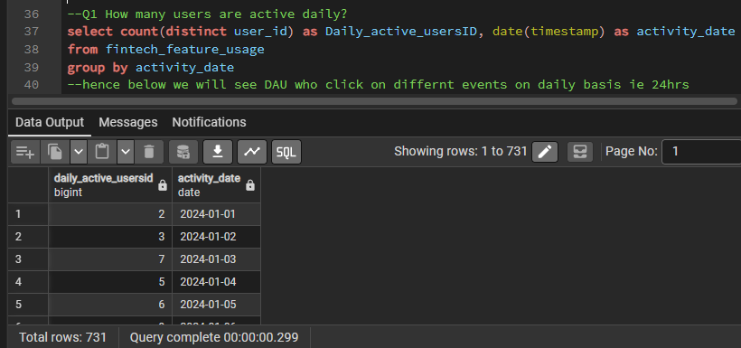
2) Monthly Active Users (MAU) – Tracked monthly user engagement trends.
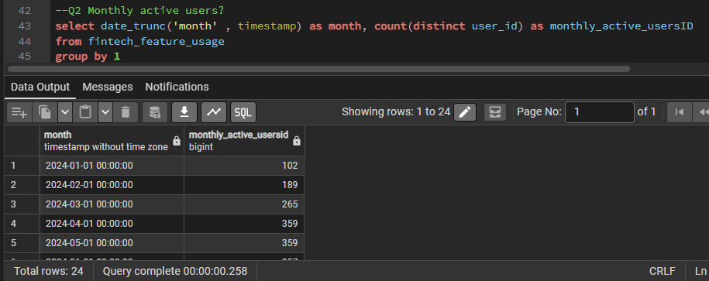
3) Retention Analysis – Calculated D1 and D7 retention to evaluate how many users returned after signup.
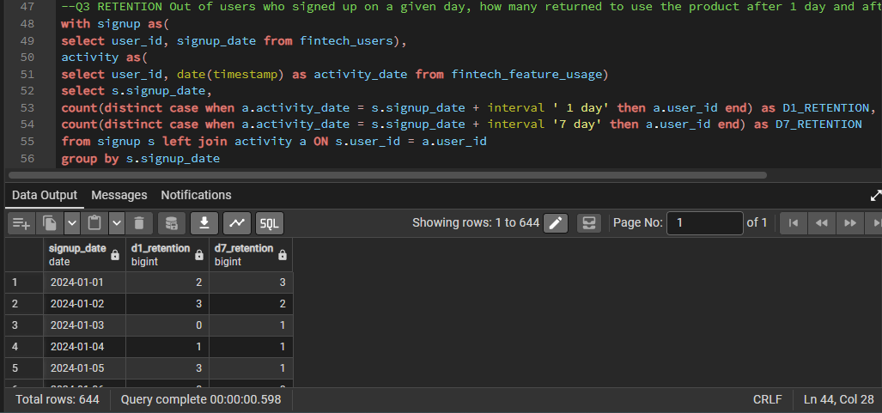
4) Churn Analysis – Identified users who became inactive for 30 days or more.
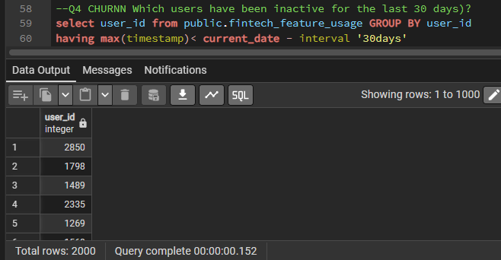
5) Funnel Analysis – Analyzed user progression through Signup → KYC → Login → Transaction stages.
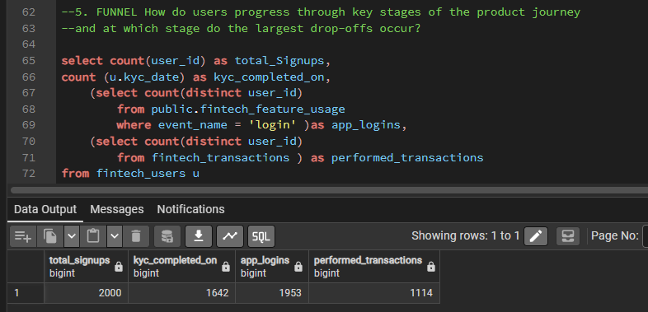
6) Conversion Rate – Measured the percentage of users completing KYC verification.
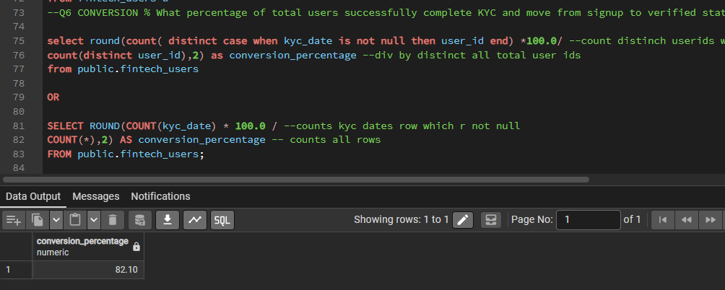
7) Feature Adoption Analysis – Evaluated adoption rates of key product features such as login, app_open, notification_click, and check_balance.
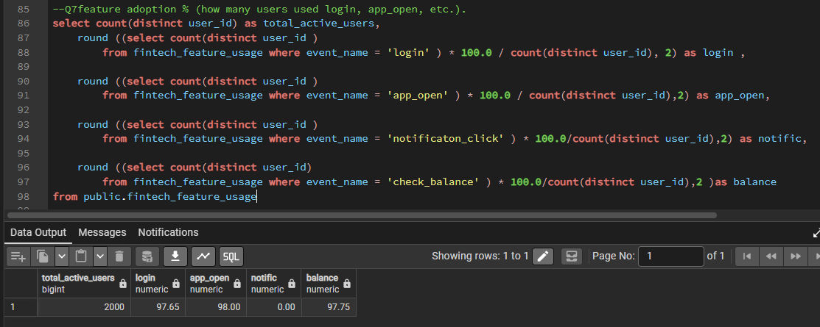
8) Customer Acquisition Analysis – Measured monthly user acquisition trends and identified peak growth periods
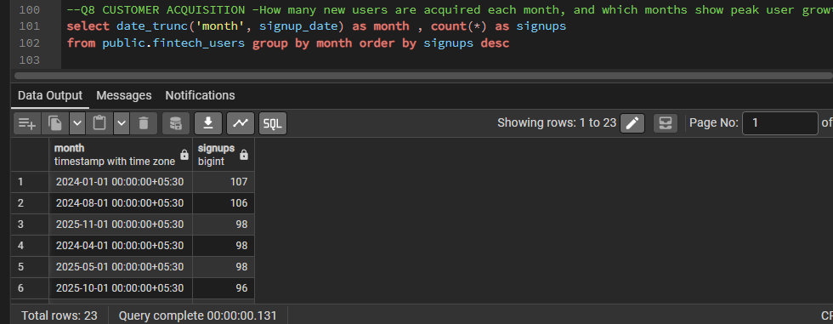
9) Monthly Churn Rate – Calculated subscription churn trends based on subscription end dates.
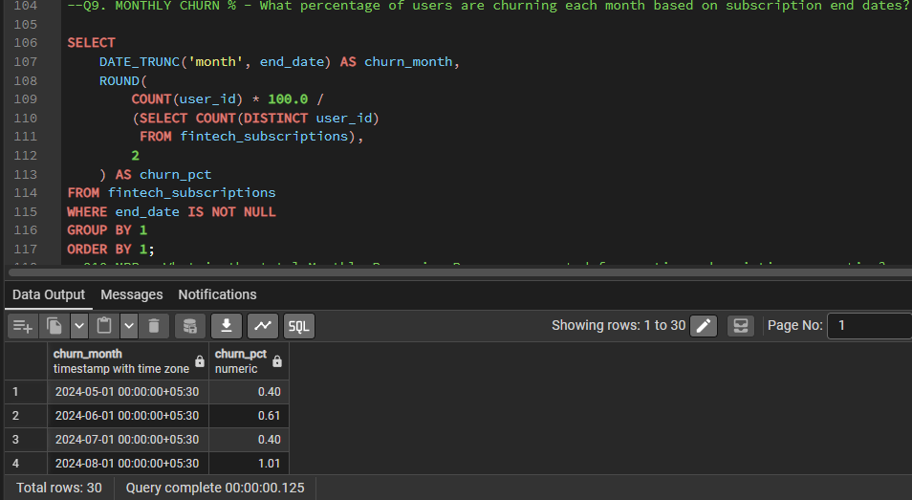
10) Monthly Recurring Revenue (MRR) – Measured recurring subscription revenue over time.
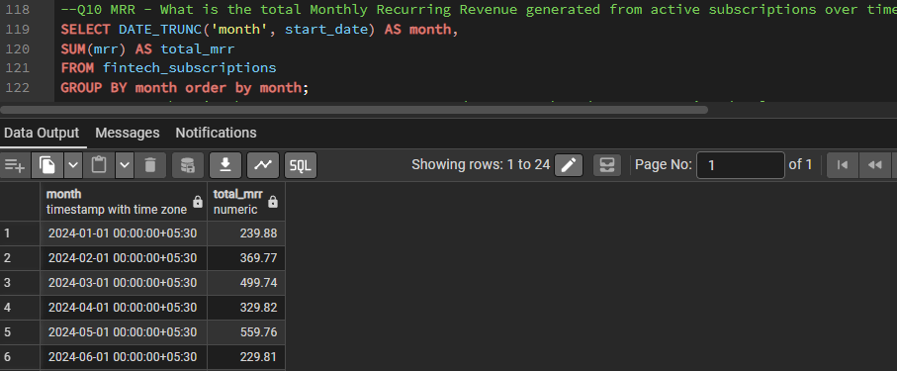
11) Average Revenue Per User (ARPU) – Calculated average revenue generated per user.
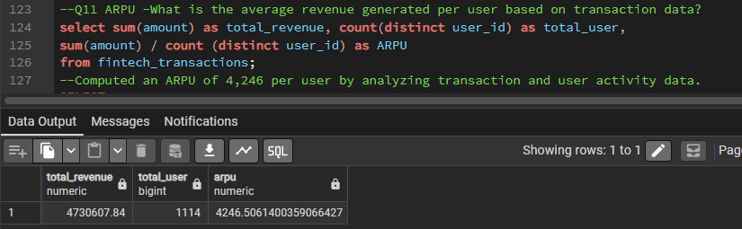
12) Revenue by Country – Identified the highest revenue-contributing regions.
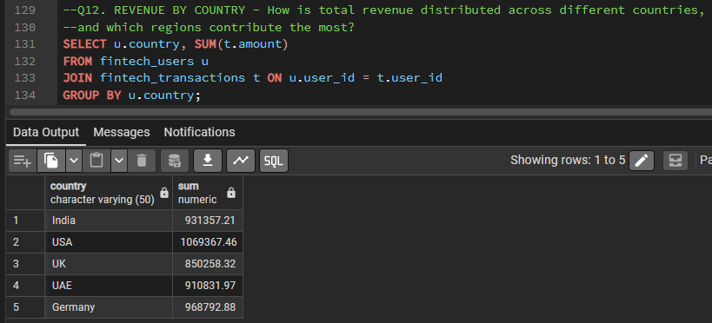
13) MAU Percentage – Measured active user percentage relative to the total user base.
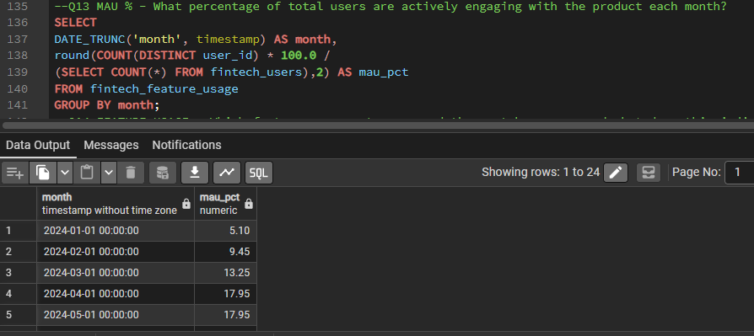
14) Feature Usage Analysis – Identified the most frequently used product features.
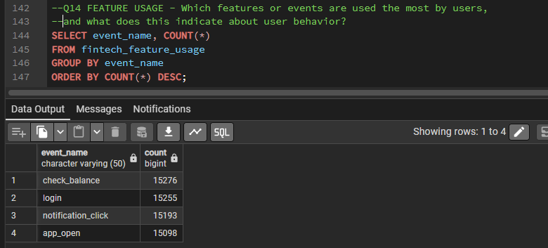
15) Funnel Drop-Off Analysis – Measured user losses between Signup, KYC, and Transaction stages.
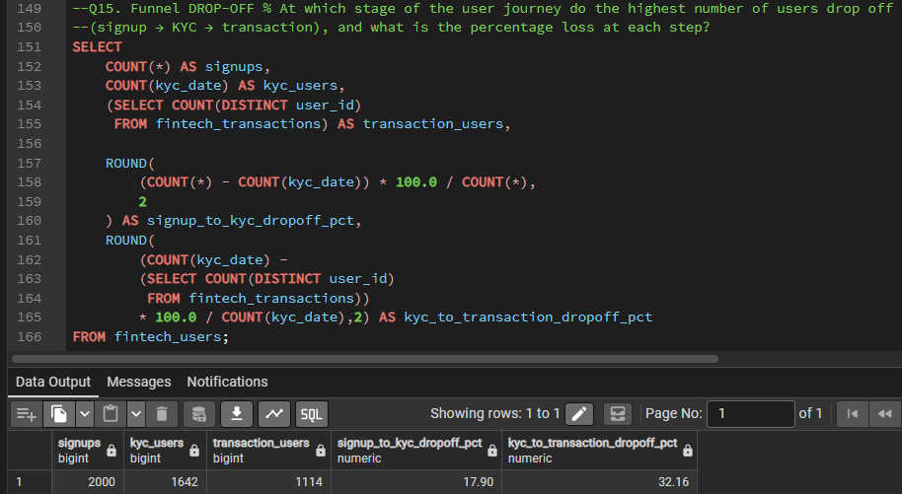

4. COHORT & RETENTION ANALYSIS USING PYTHON
Python was used to perform cohort-based retention analysis and visualize user engagement patterns over time. The objective was to understand how effectively users were retained after signup and identify trends in user engagement across different cohorts.

Step 1: Data Loading and Preparation
The datasets were imported into Python using the Pandas library and loaded into DataFrames for analysis. Initial data inspection was performed to verify column names, data types, and dataset structure.
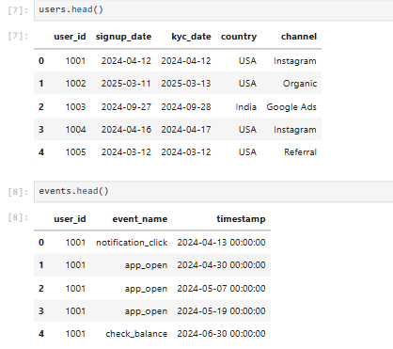

Step 2: Cohort Creation
Users were grouped into cohorts(group based on similarity) based on their signup month. Each cohort represents a group of users who joined the platform during the same month.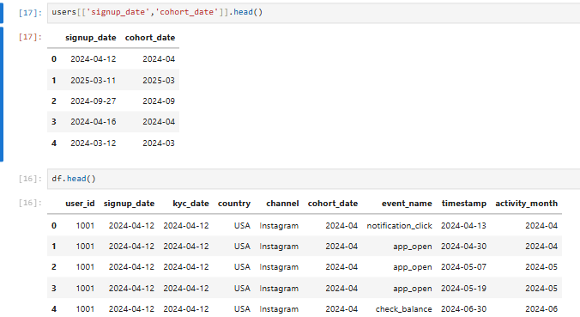

Step 3: Retention Table Generation
User activity data was merged with user information to calculate cohort-wise retention. Activity months and cohort indices were generated to track how many months users remained active after signup. A cohort pivot table was then created to organize retention data.
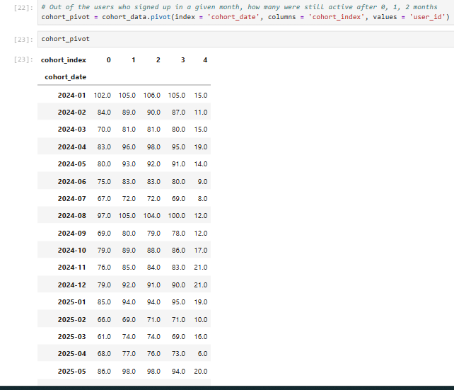

Step 4: Retention Heatmap
A retention heatmap was generated using Seaborn and Matplotlib to visualize retention percentages across different cohorts. Darker cells represent higher retention, while lighter cells indicate lower retention.
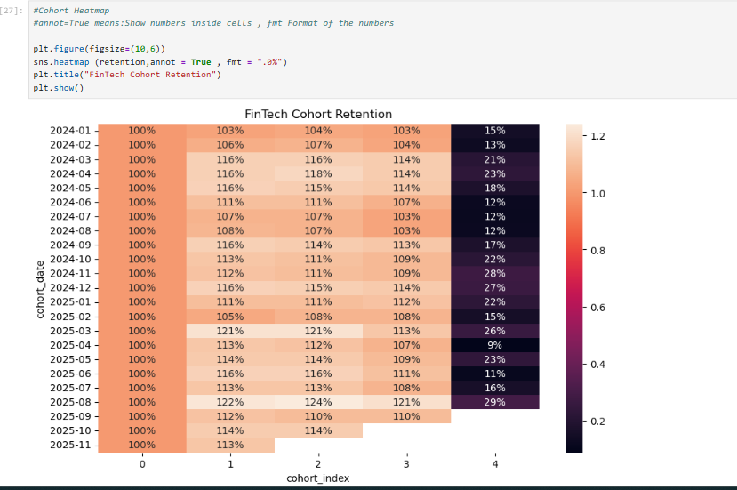
The heatmap provides a visual representation of how user retention changes over time. It helps identify cohorts with strong retention performance and cohorts experiencing higher user drop-off.

Step 5: Retention Curve
A retention curve was plotted to compare retention trends across different cohorts over multiple months. Each line represents a signup cohort, while the y-axis represents retention percentage.
